Grant Harvey

Iterative Deepening Depth-First Search (IDDFS) Implementation
In this project, I implemented an Iterative Deepening Depth-First Search function to solve the 8-puzzle problem. The algorithm incrementally increases a depth limit and performs a depth-first search up to that limit until the goal configuration is found.
The search begins from an initial puzzle state and attempts to reach the goal state [0,1,2,3,4,5,6,7,8], where 8 represents the blank tile. For each depth limit, the algorithm does a DFS and avoids revisiting previously explored states by storing visited configurations as tuples in a set. This prevents infinite loops and redundant searches.
When the goal state is reached, the algorithm reconstructs the solution path by tracking the sequence of tile moves. The path is built during recursion and reversed before returning to reflect the correct order of moves.
Achievements:
- Successfully implemented Iterative Deepening DFS
- Prevented repeated state exploration using a visited set.
- Correctly reconstructed a solution path once the goal state was found.
Limitations:
- The depth limit increment step could be optimized to ensure all possible solution depths are explored.
- Performance may degrade for deeper solutions due to repeated DFS calls.
- A* search is not yet implemented and will be completed in a future project.
Snapshots Included:
- Initial scrambled board configuration.
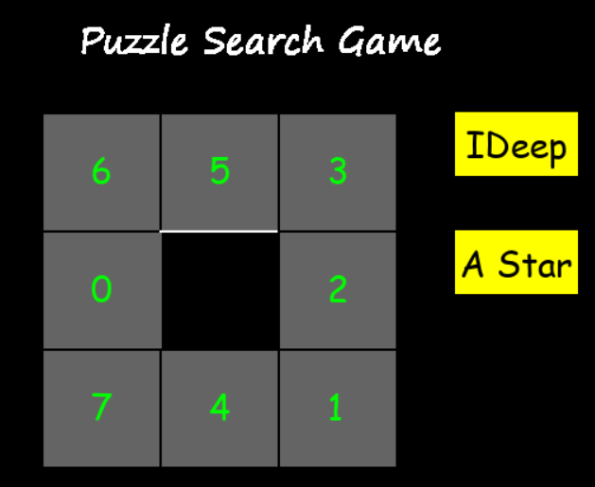

- Final completed board configuration.
